Multinomial and Bernoulli Naive Bayes¶
For understanding Multinomial and Bernoulli Naive Bayes, we will start with a small example and understand the end to end process. In another notebook, we will build a full-fledged email spam classifier.
To start with, let's take a few sentences and classify them in two different classes - education or cinema. Each sentence will represent one document. In real-world cases, a document be any piece of text such as an email, a news article, a book review, a tweet etc. The analysis and the algorithm involved doesn’t depend on the type of document we use.
The notebook is divided into the following sections:
- Importing and preprocessing data
- Building the model: Multinomial Naive Bayes
- Building the model: Bernoulli Naive Bayes

1. Importing and Preprocessing Data¶
Let us first look at the sentences and their classes. We have kept the training sentences in file example_train.csv. Test sentences have been put in the file example_test.csv.
In [129]:
import numpy as np
import pandas as pd
import sklearn

# training data
train_docs = pd.read_csv('example_train.csv')
train_docs
Out[129]:
 | Document | Class
0 | Upgrad is a great educational institution. | education
1 | Educational greatness depends on ethics | education
2 | A story of great ethics and educational greatness | education
3 | Sholey is a great cinema | cinema
4 | good movie depends on good story | cinema
So as you can see there are 5 documents (sentences) , 3 are of "education" class and 2 are of "cinema" class.
In [130]:
# convert label to a numerical variable
train_docs['Class'] = train_docs.Class.map({'cinema':0, 'education':1})
train_docs
Out[130]:
 | Document | Class
0 | Upgrad is a great educational institution. | 1
1 | Educational greatness depends on ethics | 1
2 | A story of great ethics and educational greatness | 1
3 | Sholey is a great cinema | 0
4 | good movie depends on good story | 0
Let's now split the dataframe into X and y labels.
In [131]:
# convert the df to a numpy array
train_array = train_docs.values

# split X and y
X_train = train_array[:,0]
y_train = train_array[:,1]
y_train = y_train.astype('int') # sklearn needs y as integers

print("X_train")
print(X_train)
print("y_train")
print(y_train)
X_train
['Upgrad is a great educational institution.'
'Educational greatness depends on ethics'
'A story of great ethics and educational greatness'
'Sholey is a great cinema' 'good movie depends on good story']
y_train
[1 1 1 0 0]

Creating the Bag of Words Representation¶
We now have to convert the data into a format which can be used for training the model. We'll use the bag of words representation for each sentence (document).
Imagine breaking X in individual words and putting them all in a bag. Then we pick all the unique words from the bag one by one and make a dictionary of unique words.
This is called vectorization of words. We have the class CountVectorizer() in scikit learn to vectorize the words.
In [164]:
# create an object of CountVectorizer() class
from sklearn.feature_extraction.text import CountVectorizer
# help(CountVectorizer)
In [133]:
vec = CountVectorizer()
Here vec is an object of class CountVectorizer(). This has a method called fit() which converts a corpus of documents to a matrix of 'tokens'.
In [134]:
# fit the vectorizer on training data
vec.fit(X_train)
vec.vocabulary_
Out[134]:
{'and': 0,
'cinema': 1,
'depends': 2,
'educational': 3,
'ethics': 4,
'good': 5,
'great': 6,
'greatness': 7,
'institution': 8,
'is': 9,
'movie': 10,
'of': 11,
'on': 12,
'sholey': 13,
'story': 14,
'upgrad': 15}
Countvectorizer() has converted the documents into a set of unique words alphabetically sorted and indexed.
Stop Words
We can see a few trivial words such as 'and','is','of', etc. These words don't really make any difference in classyfying a document. These are called stop words. So we would like to get rid of them.
We can remove them by passing a parameter stop_words='english' while instantiating Countvectorizer() as follows:
In [135]:
# fitting the vectorizer on training data again
# removing the stop words this time
vec = CountVectorizer(stop_words='english')
vec.fit(X_train)
vec.vocabulary_
Out[135]:
{'cinema': 0,
'depends': 1,
'educational': 2,
'ethics': 3,
'good': 4,
'great': 5,
'greatness': 6,
'institution': 7,
'movie': 8,
'sholey': 9,
'story': 10,
'upgrad': 11}
Notice that the vocabulary has reduced to 12 from 15. Another way of printing the 'vocabulary' is as follows:
In [136]:
# printing feature names
print(vec.get_feature_names())
print(len(vec.get_feature_names()))
['cinema', 'depends', 'educational', 'ethics', 'good', 'great', 'greatness', 'institution', 'movie', 'sholey', 'story', 'upgrad']
12
So our final dictionary is made of 12 words (after discarding the stop words). Now, to do classification, we need to represent all the documents with these words (or tokens) as features.
Every document will be converted into a feature vector representing presence of these words in that document. Let's convert each of our training documents in to a feature vector.
In [137]:
# another way of representing the features
X_transformed = vec.transform(X_train)
X_transformed
Out[137]:
<5x12 sparse matrix of type '<class 'numpy.int64'>'
with 20 stored elements in Compressed Sparse Row format>
You can see X_tranformed is a 5 x 12 sparse matrix. It has 5 rows for each of our 5 documents and 12 columns each for one word of the dictionary which we just created. Let us print X_transformed.
In [138]:
print(X_transformed)
(0, 2) 1
(0, 5) 1
(0, 7) 1
(0, 11) 1
(1, 1) 1
(1, 2) 1
(1, 3) 1
(1, 6) 1
(2, 2) 1
(2, 3) 1
(2, 5) 1
(2, 6) 1
(2, 10) 1
(3, 0) 1
(3, 5) 1
(3, 9) 1
(4, 1) 1
(4, 4) 2
(4, 8) 1
(4, 10) 1
This representation can be understood as follows:
Consider first 4 rows of the output: (0,2), (0,5), (0,7) and (0,11). It says that the first document (index 0) has 7th , 2nd , 5th and 11th 'word' present in the document, and that they appear only once in the document- indicated by the right hand column entry.
Similarly, consider the entry (4,4) (third from bottom). It says that the fifth document has the fifth word present twice. Indeed, the 5th word('good') appears twice in the 5th document.
In real problems, you often work with large documents and vocabularies, and each document contains only a few words in the vocabulary. So it would be a waste of space to store the vocabulary in a typical dataframe, since most entries would be zero. Also, matrix products, additions etc. are much faster with sparse matrices. That's why we use sparse matrices to store the data.
Let us convert this sparse matrix into a more easily interpretable array:
In [139]:
# converting transformed matrix back to an array
# note the high number of zeros
X_transformed.toarray()
Out[139]:
array([[0, 0, 1, 0, 0, 1, 0, 1, 0, 0, 0, 1],
[0, 1, 1, 1, 0, 0, 1, 0, 0, 0, 0, 0],
[0, 0, 1, 1, 0, 1, 1, 0, 0, 0, 1, 0],
[1, 0, 0, 0, 0, 1, 0, 0, 0, 1, 0, 0],
[0, 1, 0, 0, 2, 0, 0, 0, 1, 0, 1, 0]])
To make the dataset more readable, let us examine the vocabulary and the document-term matrix together in a pandas dataframe. The way to convert a matrix into a dataframe is pd.DataFrame(matrix, columns=columns).
In [140]:
# converting matrix to dataframe
pd.DataFrame(X_transformed.toarray(),
columns=vec.get_feature_names())
Out[140]:
 | cinema | depends | educational | ethics | good | great | greatness | institution | movie | sholey | story | upgrad
0 | 0 | 0 | 1 | 0 | 0 | 1 | 0 | 1 | 0 | 0 | 0 | 1
1 | 0 | 1 | 1 | 1 | 0 | 0 | 1 | 0 | 0 | 0 | 0 | 0
2 | 0 | 0 | 1 | 1 | 0 | 1 | 1 | 0 | 0 | 0 | 1 | 0
3 | 1 | 0 | 0 | 0 | 0 | 1 | 0 | 0 | 0 | 1 | 0 | 0
4 | 0 | 1 | 0 | 0 | 2 | 0 | 0 | 0 | 1 | 0 | 1 | 0
This table shows how many times a particular word occurs in document. In other words, this is a frequency table of the words.
A corpus of documents can thus be represented by a matrix with one row per document and one column per token (e.g. word) occurring in the corpus.
Let's now import and transform the test data as well.
In [153]:
# test data
test_docs = pd.read_csv('example_test.csv')
test_docs
Out[153]:
 | Document | Class
0 | very good educational institution | education
In [154]:
# convert label to a numerical variable
test_docs['Class'] = test_docs.Class.map({'cinema':0, 'education':1})
test_docs
Out[154]:
 | Document | Class
0 | very good educational institution | 1
In [155]:
# convert to numpy array
test_numpy_array = test_docs.values

# split into X and y
X_test = test_numpy_array[:,0]
y_test = test_numpy_array[:,1]

print("X_test")
print(X_test)
print("y_test")
print(y_test)
X_test
['very good educational institution']
y_test
[1]
In [156]:
# transform the test data
# note that you *never* fit on test data, only on training data
# and only transform the test data
X_test_transformed = vec.transform(X_test)
X_test_transformed
Out[156]:
<1x12 sparse matrix of type '<class 'numpy.int64'>'
with 3 stored elements in Compressed Sparse Row format>
In [157]:
# convert to non-sparse array
X_test=X_test_transformed.toarray()
X_test
Out[157]:
array([[0, 0, 1, 0, 1, 0, 0, 1, 0, 0, 0, 0]])
Let us summarise all we have done till now:
- vect.fit(train) learns the vocabulary of the training data
- vect.transform(train) uses the fitted vocabulary to build a document-term matrix from the training data
- vect.transform(test) uses the fitted vocabulary to build a document-term matrix from the testing data (and ignores tokens it hasn't seen before)

2. Building the Model: Multinomial Naive Bayes¶
In [158]:
# building a multinomial NB model
from sklearn.naive_bayes import MultinomialNB

# instantiate NB class
mnb=MultinomialNB()

# fitting the model on training data
mnb.fit(X_transformed, y_train)

# note that we are using the sparse matrix X_transformed,
# though you can also use the non-sparse version
# mnb.fit(X_transformed.toarray(), y_train)

# predicting probabilities of test data
proba = mnb.predict_proba(X_test)
Out[158]:
array([[0.32808399, 0.67191601]])
In [159]:
# probability of each class (test data)
print("probability of test document belonging to class CINEMA" , proba[:,0])
print("probability of test document belonging to class EDUCATION" , proba[:,1])
probability of test document belonging to class CINEMA [0.32808399]
probability of test document belonging to class EDUCATION [0.67191601]

3. Building the Model: Bernoulli Naive Bayes¶
In [160]:
from sklearn.naive_bayes import BernoulliNB

# instantiating bernoulli NB class
bnb=BernoulliNB()

# fitting the model
bnb.fit(X_transformed, y_train)

# also works
# bnb.fit(X_transformed.toarray(), y_train)

# predicting probability of test data
bnb.predict_proba(X_test)
prob_bnb = bnb.predict_proba(X_test)
prob_bnb
Out[160]:
array([[0.2326374, 0.7673626]])
In the next notebook, we will use Multinomial and Bernoulli Naive Bayes to solve an interesting real problem - classifying SMSes as spam or ham. We'll also see how to decide the optimal cutoff probability and evaluate the model.

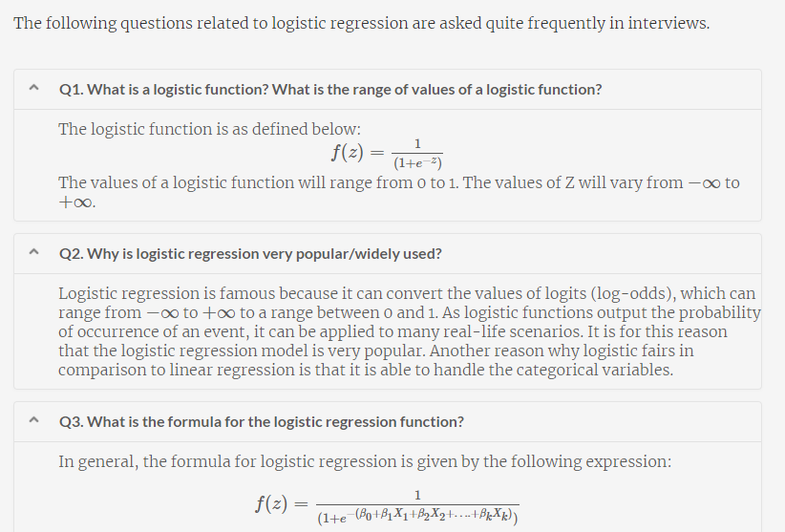
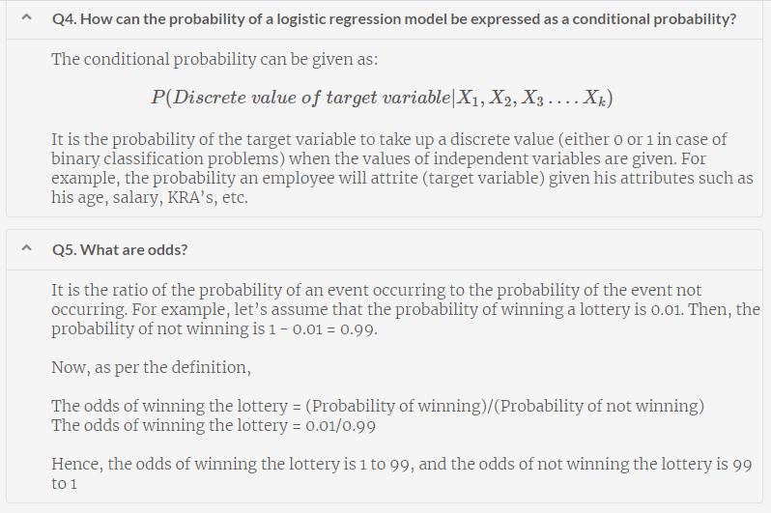
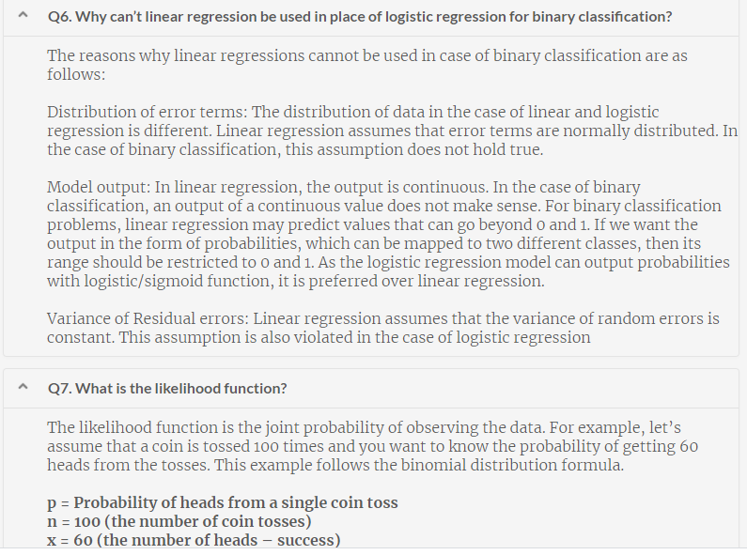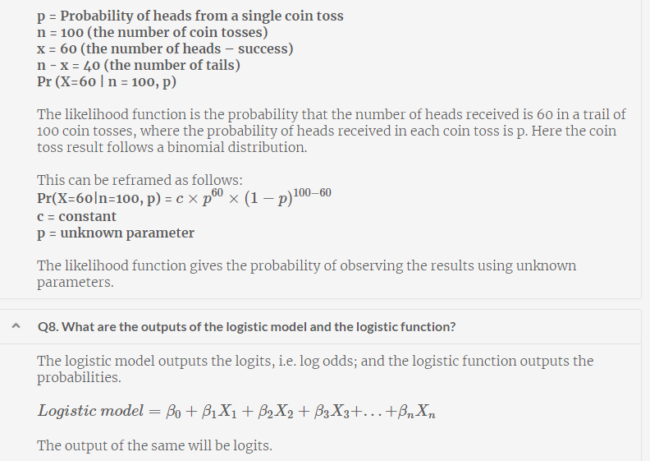
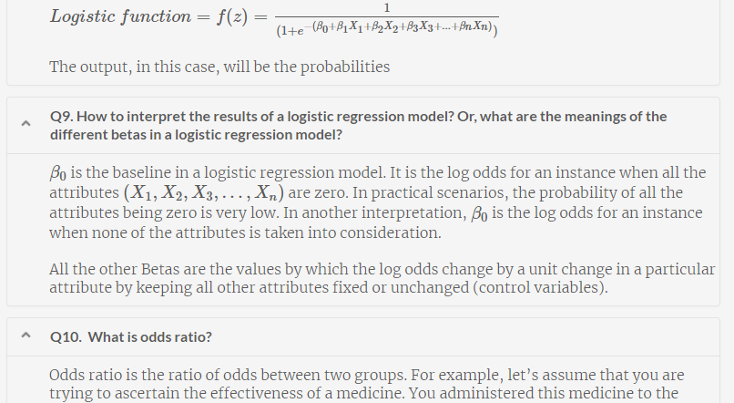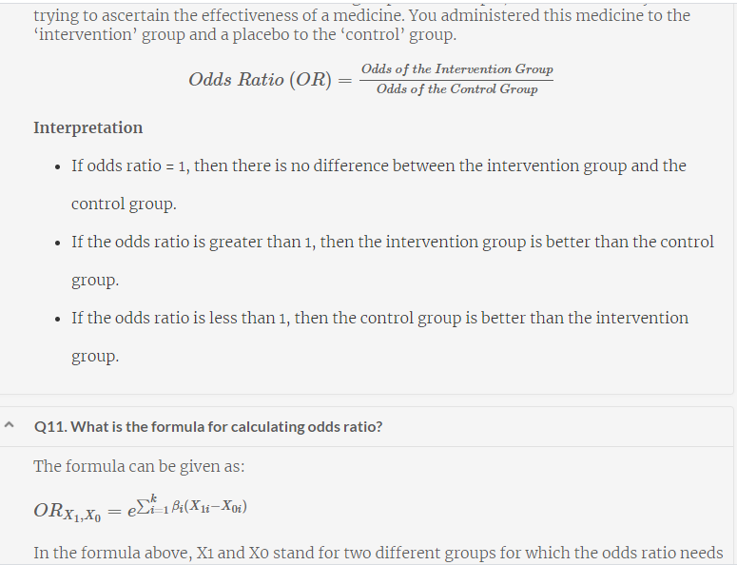
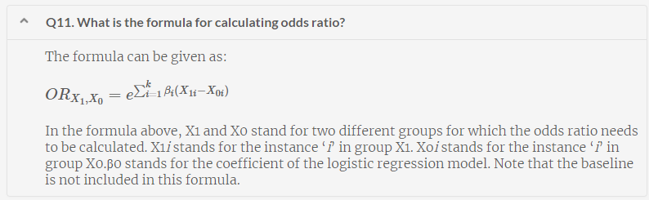

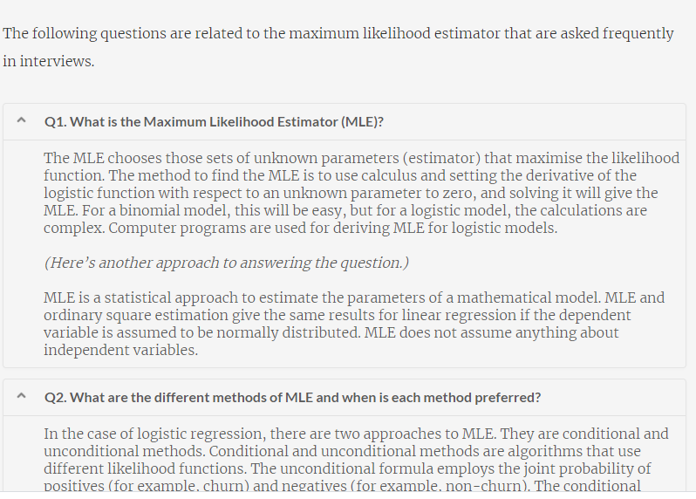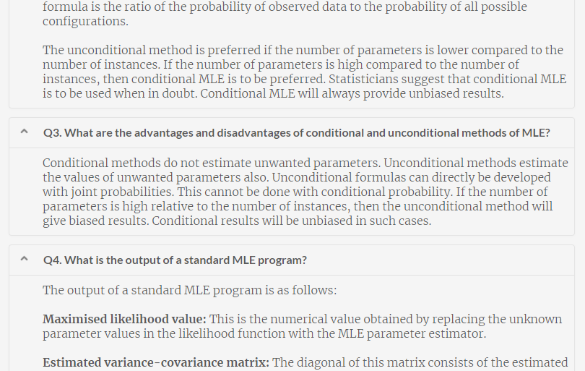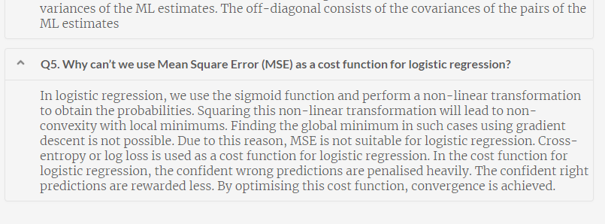
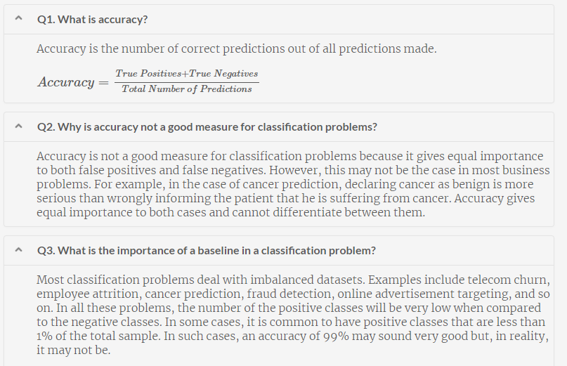
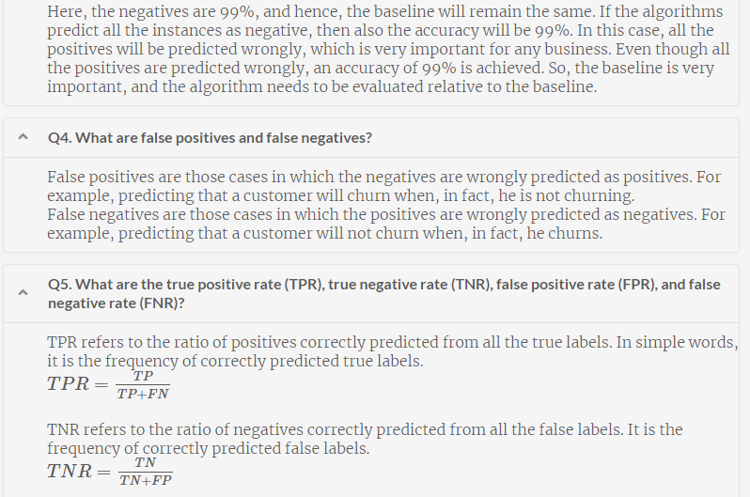
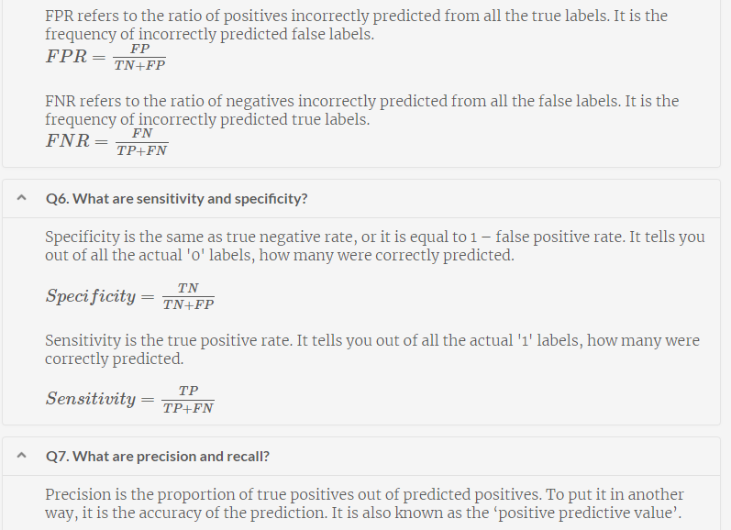
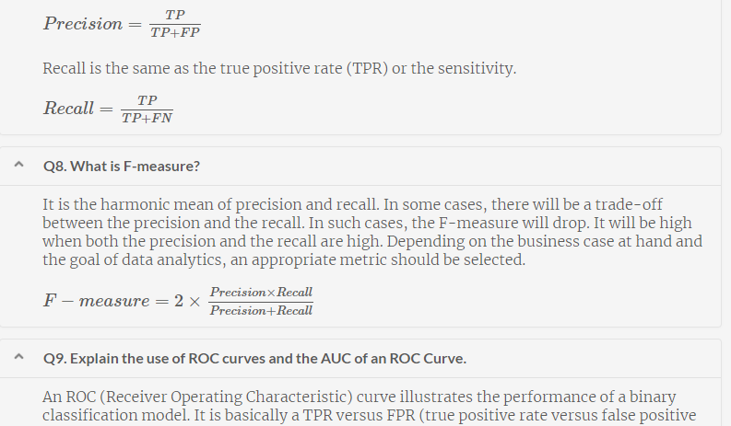
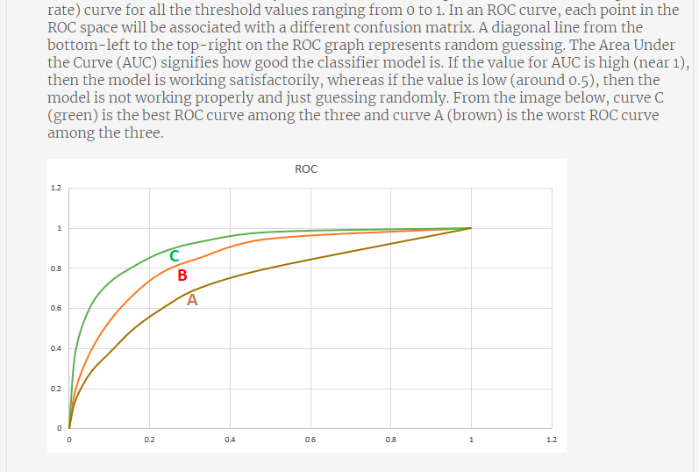
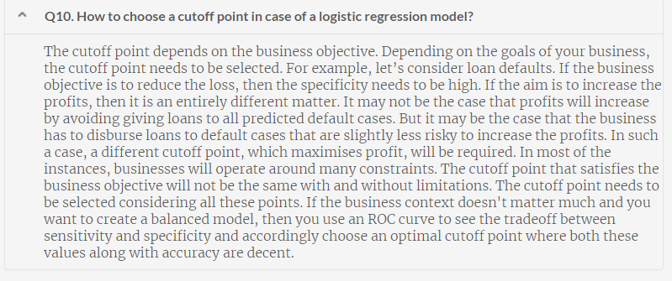

Capitalise
Description
Given a sentence as a string, capitalise the first letter of every word. Output the final sentence after capitalising.
Hint: Since strings are immutable, you need to output a new string.
Example:
Input 1:
I am now a master of Logistic regression
Output 1:
I Am Now A Master Of Logistic Regression
# Read the input string
input_string = input()

# Split the string at the white spaces so that you have the individual words
l = input_string.split(" ")

# Declare a new string since you cannot mutate strings in Python
new_s = ""

# Run a loop for all the words
for word in l:

# If the first letter of the word is in lowercase, covert it to uppercase by using
# the ord and chr functions. Note that that order of 'a' is 97 and order of 'A' is
# 65. So to capitalise, you need to subtract 32.
if(ord(word[0]) >= ord('a') and ord(word[0]) <= ord('z')):

# Add the capitalised character to the new string alongwith a white space. Then
# add the rest of the word as well.
new_s = new_s + " " + chr(ord(word[0]) - 32)
new_s = new_s + word[1:]

# If the first letter is already capital, just add the word to the new string as is
else:
new_s = new_s + " " + word

# Print the new string after doing an lstrip() since the first word was also added
# with a whitespace
print(new_s.lstrip())

Second Maximum Number in a List
Description
Given a list of numbers, find the second largest number in the list.
Note: There might be repeated numbers in the list. If there is only one number present in the list, return 'not present'.
Examples:
Input 1:
[7, 2, 0, 9, -1, 8]
Output 1:
8
Input 2:
[3, 1, 4, 4, 5, 5, 5, 0, 2, 2]
Output 2:
4
Input 2:
[6, 6, 6, 6, 6]
Output 2:
not present
# Read the input list
import ast,sys
input_str = sys.stdin.read()
input_list = ast.literal_eval(input_str)

# Declare two variables max1 and max2 which will contain the maximum and the second
# maximum element. Choose a very small number (like -10000 in this case). You will
# understand why in the next few steps
max1 = -10000
max2 = -10000

# Run a loop throughout the length of the loop
for i in input_list:

# If you encounter a number greater than max1, update the values of both max1 and max2
# max2 will now take the value of max1 and max1 will take the value of i
if(i > max1):
max2, max1 = max1, i

# Else if you encounter a number which is less than max1 but greater than max2, just
# update the value of max2
elif(i < max1 and i > max2):
max2 = i

# If max1 is equal to max2, or either of max1 and max2 are -10000 (the initial value),
# it means that only one number (repeated several times) is present in the list, so
# print not present. Else print the value of max2
if((max1 == max2) or (max1 == -10000) or (max2 == -10000)):
print("not present")
else:
print(max2)

Data Quality
Description
You have a Wholesale Customers dataset. Here are the first few rows of the dataset:
﻿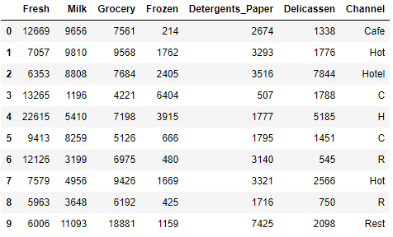﻿The last column 'Channel' contains information about the type of channel the items are supplied to. There are only three types of channels - 'Hotel', 'Restaurant', and 'Cafe'. But as you can notice, there are quality issues in the last data. A lot of the times Cafe as been written as 'C', Hotel has been written as 'Hot', etc. Inspect these incorrect values and replace them with their actual full names.
After this operation, the final column should only have 3 kinds of label - 'Hotel', 'Restaurant', and 'Cafe'.
The dataframe has already been read to you in the variable 'wholesale'.
The print statement to print the final dataframe has also been provided. You just need to perform the operations for correcting the names present in the last column.

# Importing the Pandas package and reading the data
import pandas as pd
wholesale = pd.read_csv('https://media-doselect.s3.amazonaws.com/generic/OkbnaOBqrBXZOpRQw1JGMgaM9/Wholesale_Data.csv')

def CorrectChannelName(ChannelName):
cafe_list = ['C', 'Cafe']
hotel_list = ['H', 'Hot', 'Hotel']
rest_list = ['R', 'rest']
for c_ele in cafe_list:
if c_ele in ChannelName:
return 'Cafe'

for h_ele in hotel_list:
if h_ele in ChannelName:
return 'Hotel'

for r_ele in rest_list:
if r_ele in ChannelName:
return 'Restaurant'

# The final print statement. Please don't edit this part. Also don't write any other
# print statement otherwise your answer will not match even if it is correct
wholesale['Channel'] = wholesale['Channel'].apply(CorrectChannelName)
print(wholesale['Channel'].value_counts())

# Importing the Pandas package and reading the data
import pandas as pd
wholesale = pd.read_csv('https://media-doselect.s3.amazonaws.com/generic/OkbnaOBqrBXZOpRQw1JGMgaM9/Wholesale_Data.csv')

# Inspecting the first few rows
wholesale.head(10)

# Checking the value counts of the column 'Channel' to see what all values are present
wholesale['Channel'].value_counts()

# Define a function to correct the names. Code self-explanatory
def correction(x):
if x in ['H', 'Hote', 'Hot']:
x = 'Hotel'
elif x in ['C', 'Caffe']:
x = 'Cafe'
elif x in ['R', 'Rest']:
x = 'Restaurant'
return(x)

# Apply the function written above to the column 'Channel'
wholesale['Channel'] = wholesale['Channel'].apply(lambda x: correction(x))

# Checking the final dataframe
wholesale.head()

# The final print statement. Please don't edit this part. Also don't write any other
# print statement otherwise your answer will not match even if it is correct
print(wholesale['Channel'].value_counts())

Worst Channel
Description
You again have the wholesale dataset but this time it is cleaned. Here are the first few rows:﻿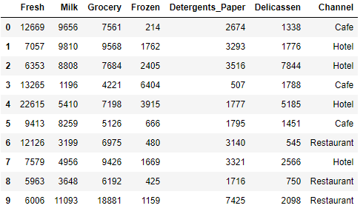﻿
Each of the columns except for the column 'Channel' tells you the sales for each kind of product and the 'Channel' column tells you which 'Channel' you're selling to. Your task is to find out which of the three channels has the least total sales (for all the products combined). For example, if the total sales to Cafe, Hotel, and Restaurant turn out to be 1 lakh, 2 lakh, and 3 lakh rupees, you need to print 'Cafe' since it has the lowest sales.

# Import Pandas and read the dataframe
import pandas as pd
wholesale = pd.read_csv('https://media-doselect.s3.amazonaws.com/generic/OqwpypRKN09x5GYej2LvVrprn/Wholesale_Data_Cleaned.csv')

# Inspect the dataframe
wholesale.head()
wholesale.shape

# Create a new column 'Total' that contains the sum of all the columns
wholesale['Total'] = wholesale.sum(axis=1)

# Inspect the dataframe again
wholesale.head()

# Group the dataframe using 'Channel' as the index, 'Total' as the values, and
# 'sum' as the aggfunc
channels = wholesale.pivot_table(index='Channel', values = 'Total', aggfunc = 'sum')

# Check the grouped dataframe
channels.head()

# Sort the grouped dataframe and print the smallest value
print(channels.sort_values(by='Total').index[0])

